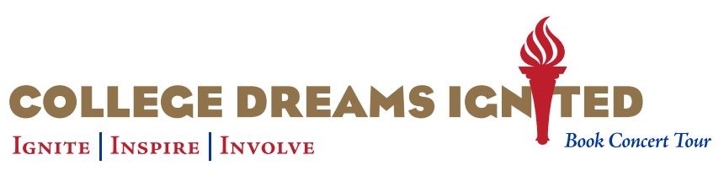

KEYNOTE

Invest in Reading: Ignite, Inspire, Involve!

Sharing moving stories of transformation and renewal, Dr. Vana Nespor fires our imagination and gives us a vision for our investment in reading as revolutionary and emancipatory for all of West Virginia.

Feature Session Workshop

Invest in Dream Reading Circles
Transforming College & Life for Women and their Children

In Spring 2016 Bay Path University President, Dr. Carol Leary, published Achieving the Dream: A How to Guide for Adult Women Seeking a College Degree. Spontaneously, people around the country began creating Dream Reading Circles to discuss the book and to support women in their dream of earning a college degree. Learn how you can use this technique to empower women, their children, and their communities.

SPEAKER BIO

Dr. Vana Nespor taught Kindergarten and high school English before finding her life’s mission when she became the director of a small college center in Petersburg, West Virginia, in the 1980s. To help men and women finish quickly, she created an accelerated degree program. The program was challenging, but the students’ determination and courage, made the difference. Everyone graduated. The success of these students transformed Nespor’s life and career. She went on to establish programs in four states bringing the program to Bay Path University in 1999 where it flourished, helping thousands of women. As the new Vice President for Special Initiatives at Bay Path, she is carrying the message to the nation. Dr. Nespor holds three masters’ degrees and a doctorate in Adult Learning from Teacher’s College at Columbia University in New York City.

